LAHC Math 260 Sequences/Patterns Project Due May 24th Sp 21 Name:
- points

- Find a sophisticated pattern in ”Fractal Math” or any other fractal idea with at least 4 iterations. It could be in two or three dimensions. If you create your own fractal pattern, not done by anybody ever; you would earn double the points. Be careful with plagiarism here.
5 points for creativity 5 points for complexity

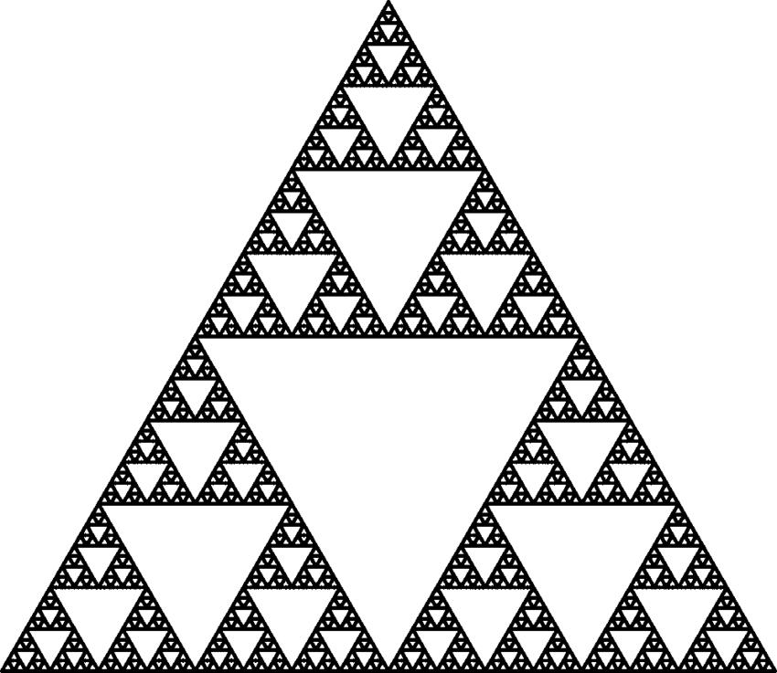

- List (complete website address and/or complete book information) of any sources used here: 2 points

https://www.researchgate.net/figure/a-The-Sierpinski-gasket-b-The-Sierpinski-carpet_fig1_228922573

- List the materials used for the project. It cannot be computer generated. 2 points
- A plain/ graph paper.
- A pencil.
- A ruler.
- A compass.
- An eraser.
- A sharpener.

4) Write in your own words (in the space bellow or as an attachment) how you created the project. Again, it cannot be computer generated. Describe in great detail the patterns being created. Example. The length of the hypotenuse is half of the previous one.
5 points (printed papers from the websites do not count)

- Draw an equilateral triangle
- Connect the midpoint of each side of the triangle to form four separate triangles. shade all the triangles formed apart from the triangle in the middle.
- Repeat the steps 1,2,3 on the three black triangles left. Ensure that you shade the triangles at the center neatly of each black triangle well for a pleasing outcome.
- Continue with the steps infinitely depending on the number of times you need.

- Display. 10 points
Step 1;
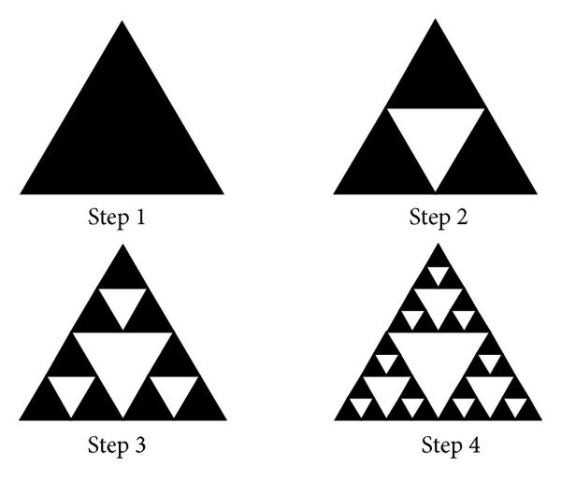

- Find the “formula for at least one of the patterns described in 4)” calculate four iterations. Write it in the space bellow or as an attachment:
10 points

A_{n} =1/3 ∑_{i= 1}^{N} (3/4)^I
An= is the area of the holes and the circumferences of the solid pieces
i= iterations
i = 1
A₁ = 1/3 (3/4)^1 = ¼
i=2
A2 = 1/3 (3/4)^2= 3/16
i=3
A3 = 1/3(3/4)^3= 9/64
i=4
A4 = 1/3(3/4)^4=27/256

- You must upload these instructions as a “cover sheet” and any other information as needed. Also, you must take a very good picture of your project and uploaded. 1 point

- Have fun and do your best.

